# PROJECT: FLIGHT DELAY PREDICTION FOR AVIATION INDUSTRY UISNG MACHINE LEARNING.

# TEAM MEMBERS NAME:

1. KATHIRAVAN G(20UCS4260)(LEAD)
2. LOGESHWARAN S(20UCS4261)
3. NAVEENKUMAR A()
4. VARATHARAJ K()

# GITHUB LINK: <https://github.com/KathiravanCR7/NaanMudhalvan-Flight-Delay-Prediction-for-aviation-industry-using-Machine-Learning>

# 1. INTRODUCTION

1.1 Overview

**Project Description:**

OVER the last twenty years, air travel has been increasingly preferred among travelers, mainly because of its speed and in some cases comfort. This has led to phenomenal growth in air traffic and on the ground. An increase in air traffic growth has also resulted in massive levels of aircraft delays on the ground and in the air. These delays are responsible for large economic and environmental losses. According to, taxi-out operations are responsible for 4,000 tons of hydrocarbons, 8,000 tons of nitrogen oxides and 45,000 tons of carbon monoxide emissions in the United States in 2007. Moreover, the economic impact of flight delays for domestic flights in the US is estimated to be more than $19 Billion per year to the airlines and over $41 Billion per year to the national economy In response to growing concerns of fuel emissions and their negative impact on health, there is active research in the aviation industry for finding techniques to predict flight delays accurately in order to optimize flight operations and minimize delays.

Using a machine learning model, we can predict flight arrival delays. The input to our algorithm is rows of feature vector like departure date, departure delay, distance between the two airports, scheduled arrival time etc. We then use decision tree classifier to predict if the flight arrival will be delayed or not. A flight is delayed when difference between scheduled and actual arrival times is greater than 15 minutes. Furthermore, we compare decision tree classifier with logistic regression and a simple neural network for various figures of merit. Finally, it will be integrated to web based application

1.2 Purpose

# 2. PROBLEM DEFINITION & DESIGN THINKING.

2.1 Empathy Map

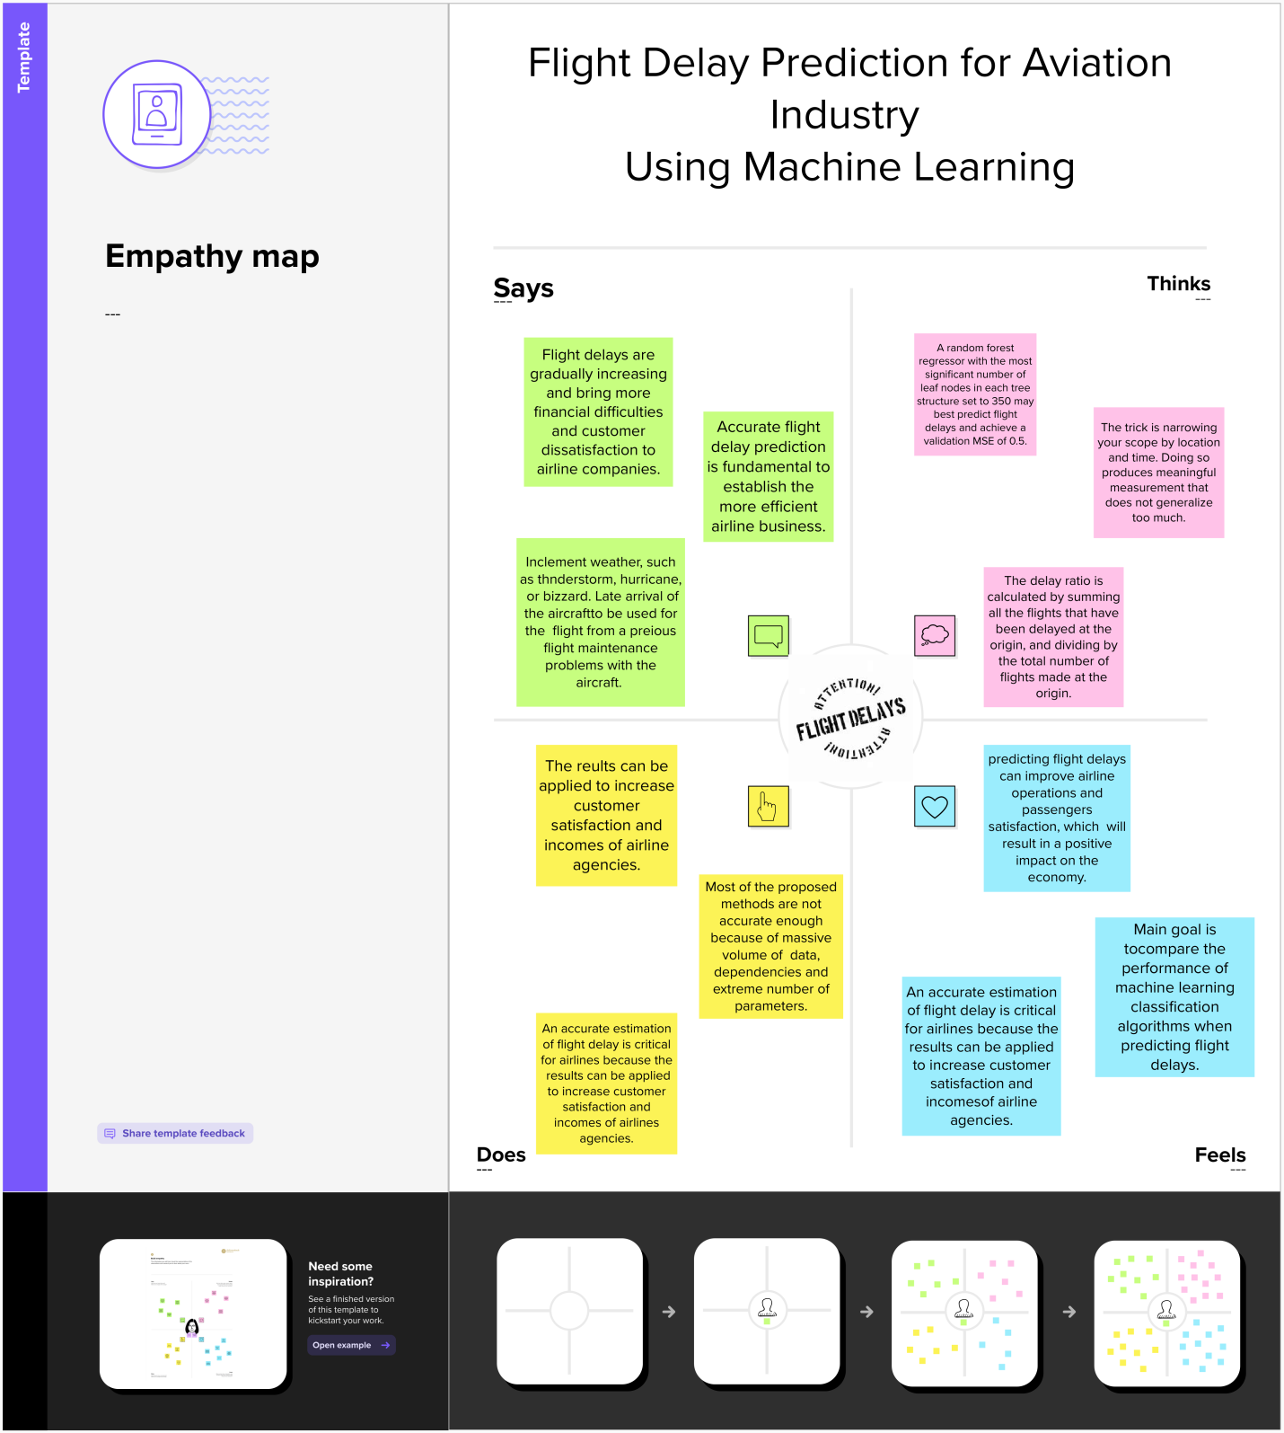

2.2 Ideation & Brainstorming Map

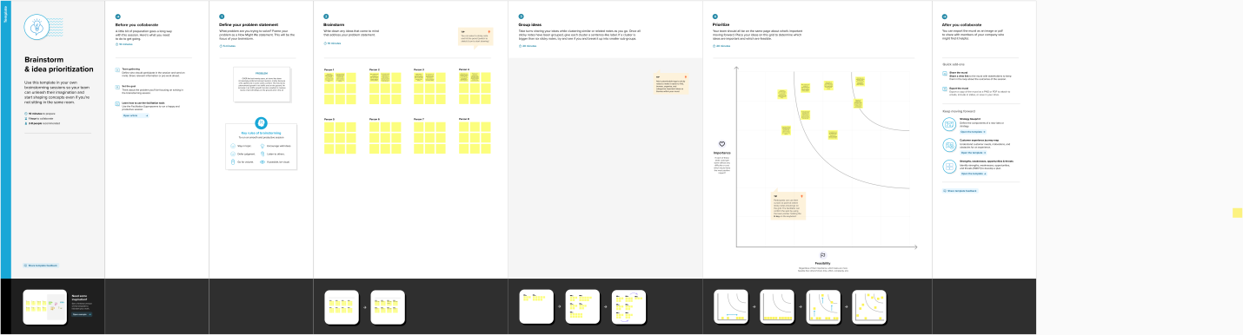

# 3. RESULT.

# 4. ADVANTAGES & DISADVANTAGES.

# 5. APPLICATIONS.

# 6. CONCLUSION.

# 7. FUTURE SCOPE.

# 8. APPENDIX.

A. Source Code.